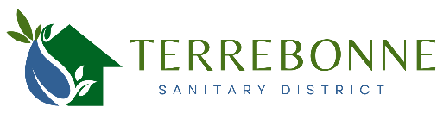

PO Box 2171, Terrebonne Oregon 97760

[terrebonnesanitary@gmail.com](mailto:terrebonnesanitary@gmail.com)

<https://tsdor.specialdistrict.org/>

(425) 224-2458

**Board Meeting Agenda**

**Thursday, May 15, 2025, at 4:00 p.m.**

**Smith Rock Community Church, 8344 11th Street, Terrebonne**

1. Call to Order
2. Pledge of Allegiance
3. Public Comments
4. Consent Agenda

April 17, 2025 Meeting Minutes (Exhibit A)

1. Discussion and Action Items
   1. Financial Report and Funding Discussion
   2. Orenco Systems
   3. Training:
      1. *Emerging Cyber Threats: Claims Mitigation Strategies* <https://www.sdao.com/emerging-cyber-threats-claims-mitigation-strategies>
2. Other Items

*These can be any items not included on the agenda that the Board members wish to discuss as part of the meeting, pursuant to ORS 192.640.*

1. Adjourn

The meeting location is accessible to persons with disabilities. At least 48 hours in advance of the meeting, Linda Swearingen, 541-350-6012, lllswear@aol.com, must be contacted to request an interpreter for the hearing impaired or other accommodations for persons with disabilities.

This meeting will be conducted electronically, by phone, in person, and using Zoom. Members of the public may listen, view, and/or participate in this meeting in real time:

|  |  |
| --- | --- |
| **Join on your computer, mobile app or room device**  Click Link below to join the meeting  https://us06web.zoom.us/j/84660061410  Meeting ID: 846 6006 1410 | **Or call in (audio only)** (Toll-free)  +1 253-205-0468,,84660061410# US  United States, Tacoma (Toll-free)  +1 253-215-8782,,84660061410# US, Tacoma |